**CSE4019 – Image Processing**

**Project Report**

**Generating a HDR image from an exposure sequence**

*By*

19BPS1025 SUCINTHAR S

19BPS1076 JARUN MADHESH

19BPS1110 ARAVIND J

B. Tech Computer Science and Engineering

*Submitted to*

**GEETHA S**

**School of Computer Science and Engineering**



*April 2022*

*­*

**ACKNOWLEDGEMENT**

We are highly grateful to Dr. **GEETHA S**, Professor, School of Computer Science and Engineering (SCOPE), Vellore Institute of Technology, Chennai for providing this great opportunity to do this review and has been of great help in sharing knowledge and helping us throughout this whole project term and is acknowledged with gratitude.

We would like to express my gratitude to other faculty members of SCOPE CSE department for their intellectual support throughout this work.

**19BPS1025 SUCINTHAR S**

**19BPS1076 JARUN MADHESH**

**19BPS1110 ARAVIND J**

**CONTENTS**

1 Abstract

2 Requirements Specification

3 Implementation Code

4 Results & Discussion

5 Conclusion and Future Work

6 References

**ABSTRACT**

Generating HDR image from a sequence of multi-exposure shots and evaluate them with different methods. HDR stands for high dynamic range. Dynamic range is simply the range of the lightest tones to the darkest tones within a photo. Put another way — it’s a measure of the light intensities from the highlights to the shadows.

The higher dynamic range your camera has, the closer the photo will compare to what an eye can see. This means that you’ll be able to capture more details in the shadows that might otherwise appear pure black, and you’ll be able to see details in the highlights that might otherwise be washed out with white.

**2** **Requirements Specification**

2.1 **Software Requirements**

Jupyter Notebook

Opencv

**Implementation Code**

Dataset link:

Burst photography for high dynamic range and low-light imaging on mobile cameras

Samuel W. Hasinoff, Dillon Sharlet, Ryan Geiss, Andrew Adams, Jonathan T. Barron, Florian Kainz, Jiawen Chen, and Marc Levoy ACM Transactions on Graphics (Proc. SIGGRAPH Asia 2016), 35(6), 12 pp.

GitHub link

**Results and Discussion**

HDR image from proposed method

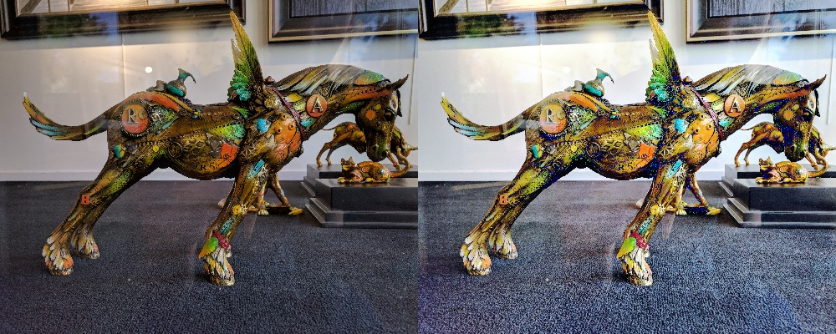

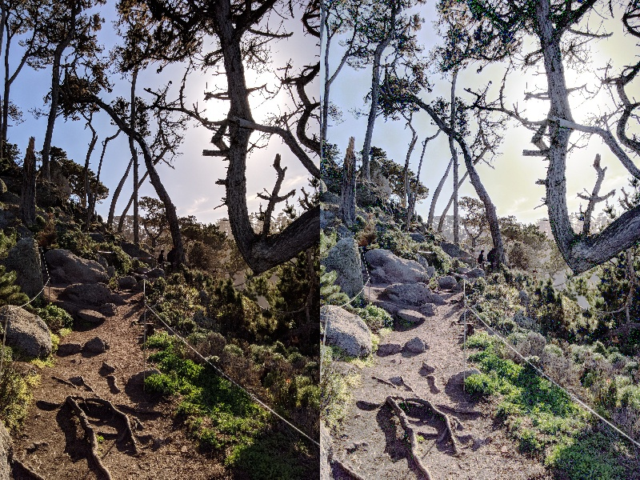

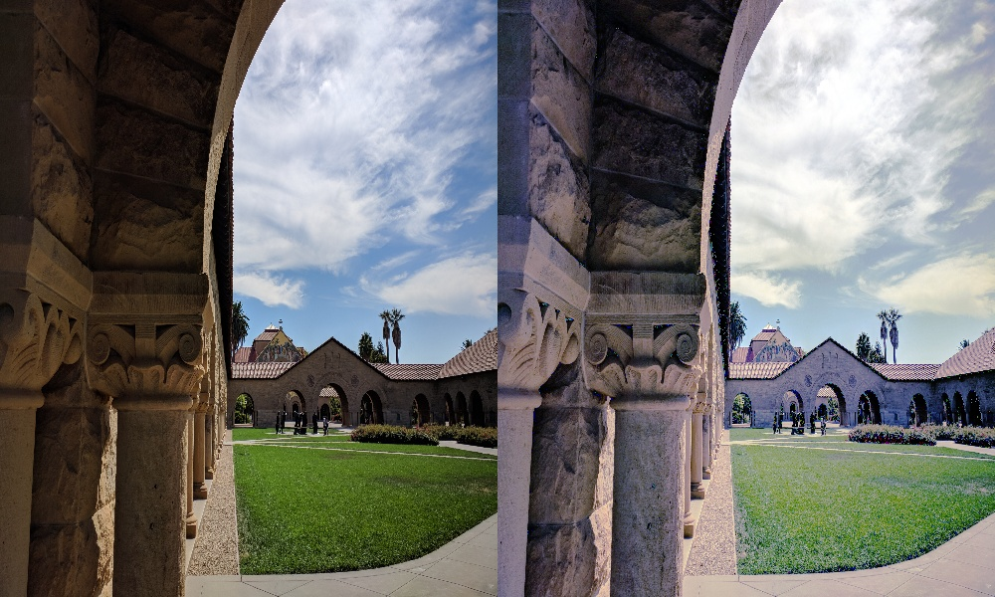

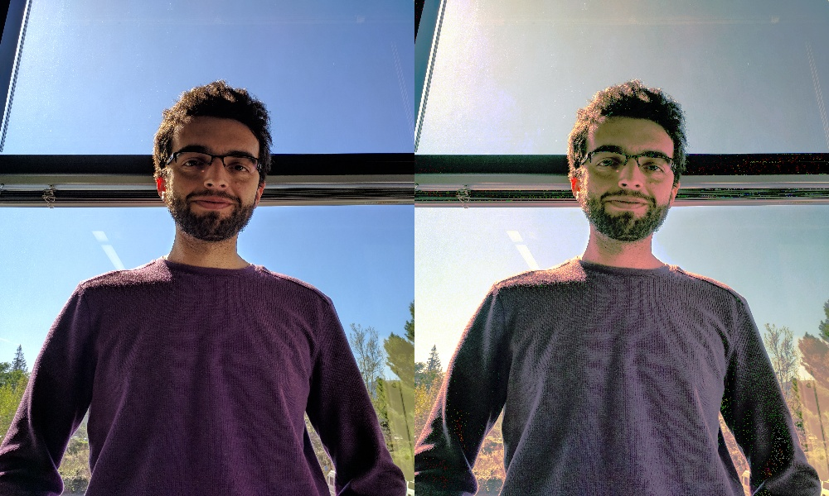

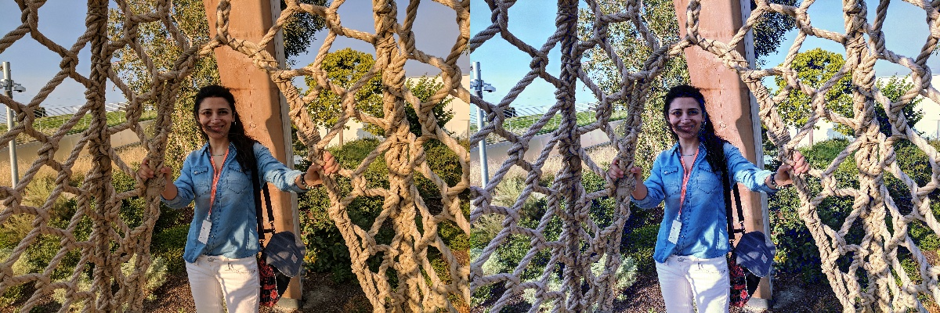

**EVALUATION**

We have analyzed the different methods and compared it with our method for generating best HDR image.

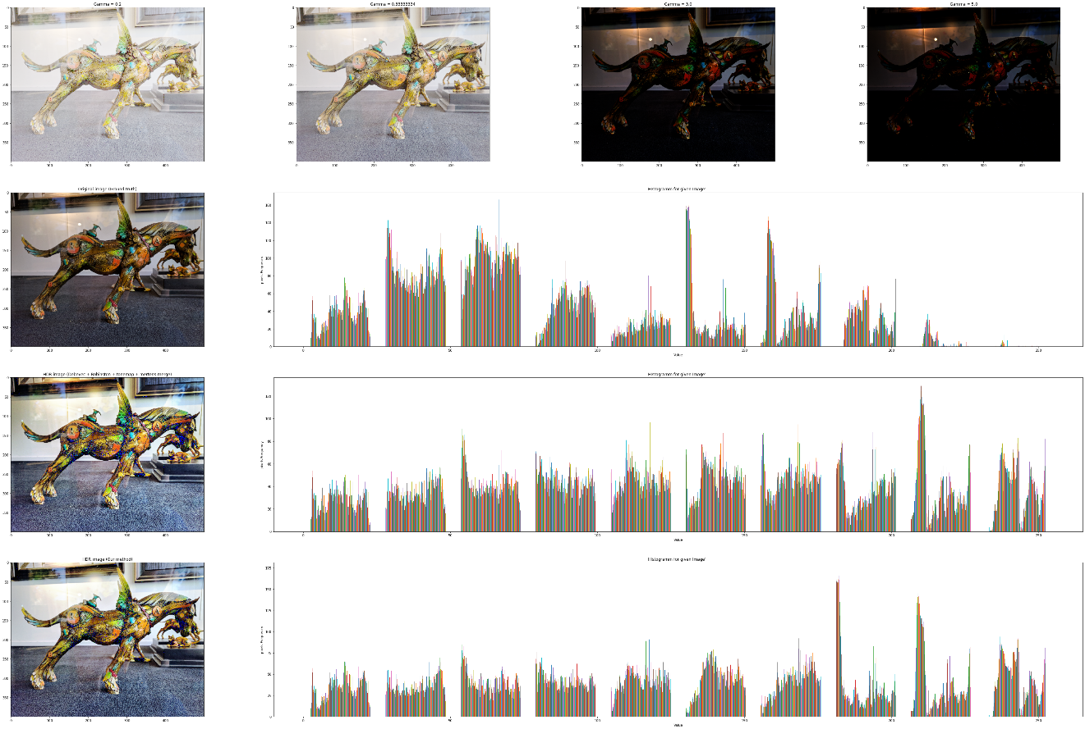

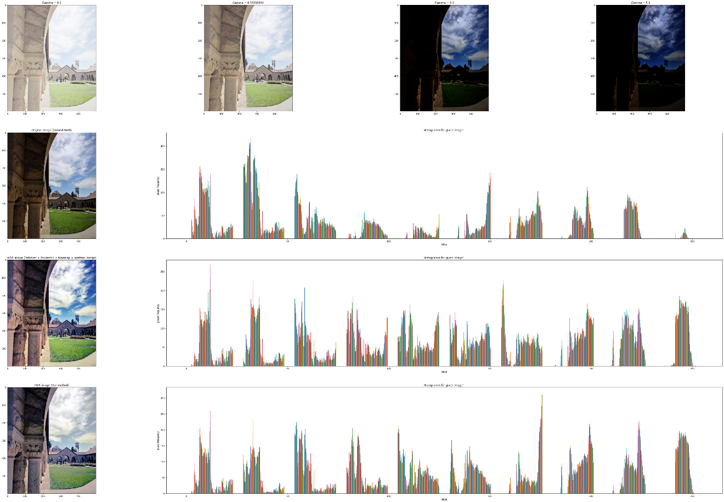

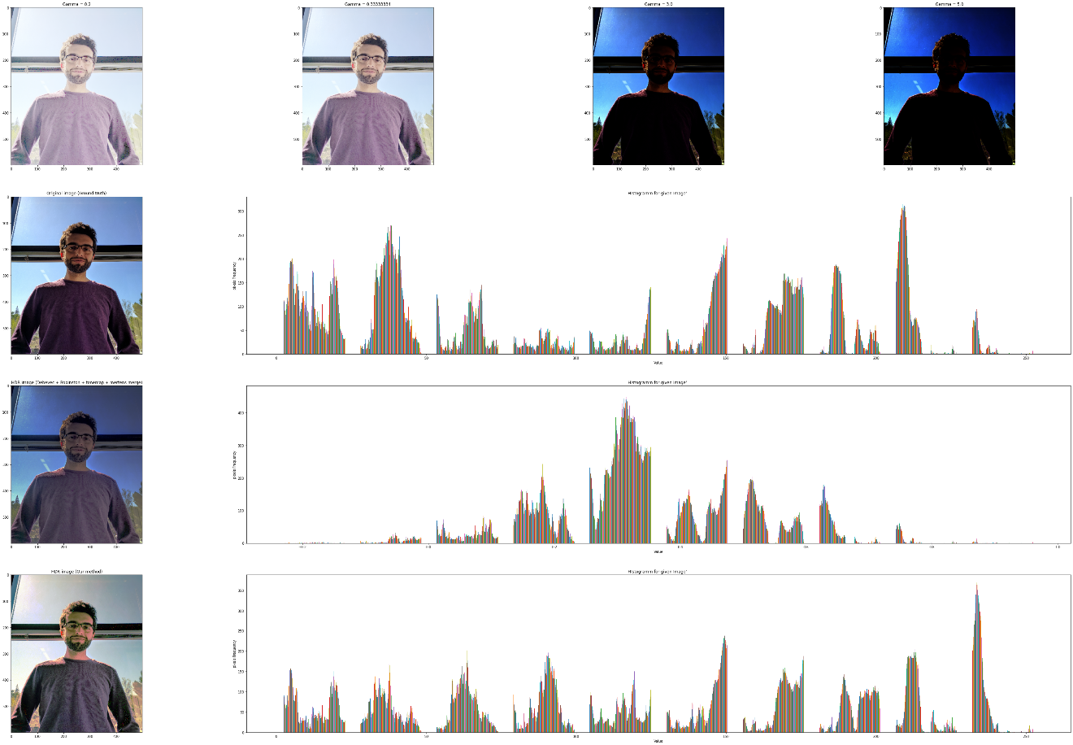

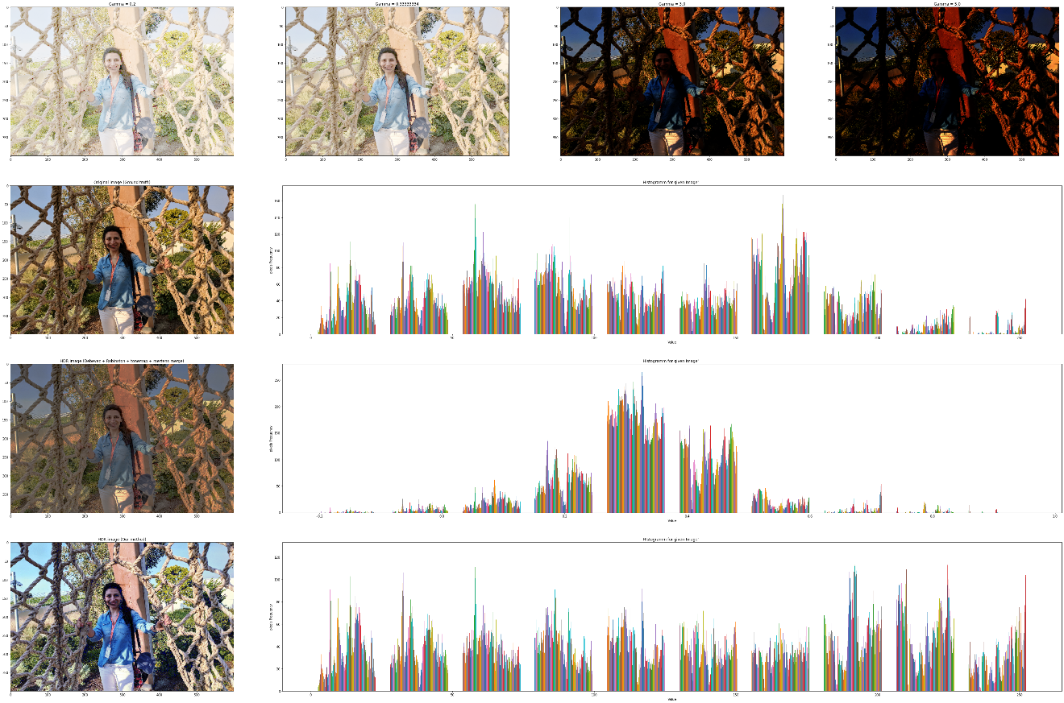

**Conclusion and Future Work**

**REFERENCES**

https://arxiv.org/abs/2106.01439

https://learnopencv.com/high-dynamic-range-hdr-imaging-using-opencv-cpp-python/

Debevec method: http://www.pauldebevec.com/Research/HDR/debevec-siggraph97.pdf

Robertson method: https://resources.mpi-inf.mpg.de/tmo/EG05_HDRTutorial_Complete.pdf

Mertens fusion: https://www.researchgate.net/publication/4295602_Exposure_Fusion

Reinhard Tonemap: https://www.cl.cam.ac.uk/~rkm38/pdfs/mantiuk08datm.pdf

https://resources.mpi-inf.mpg.de/tmo/EG05_HDRTutorial_Complete.pdf

https://ieeexplore.ieee.org/abstract/document/8350767